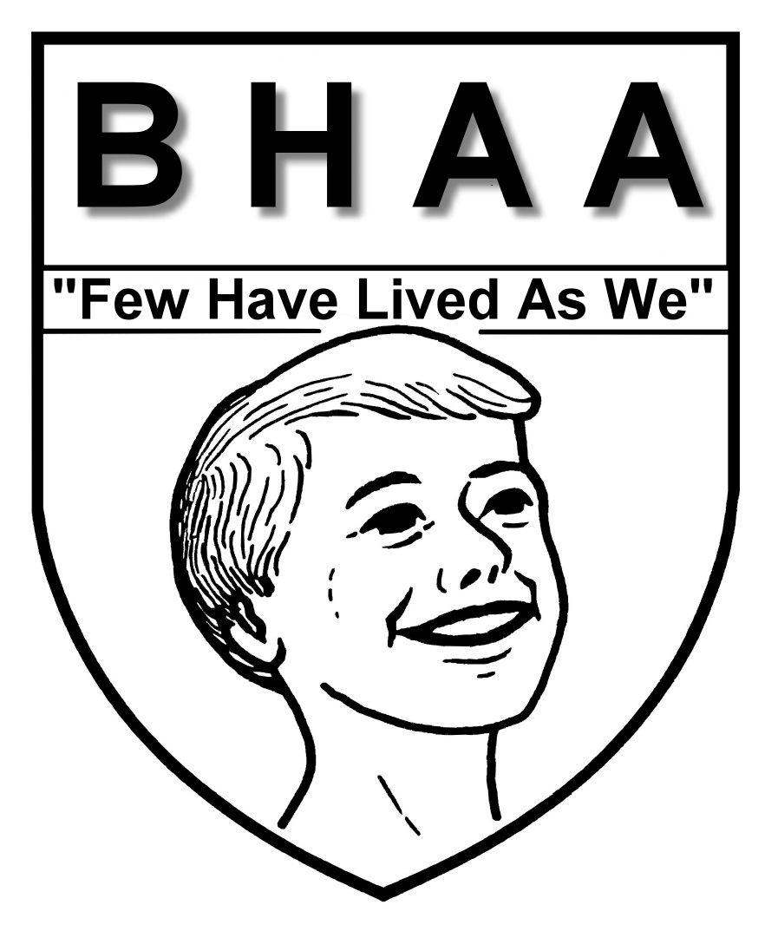

**BOYS HOME ALUMNI ASSOCIATION**

*May 3, 2024*

To: All Alumni and Friends

I hope this note finds all you and your families in good health, and life is giving you all the warm fuzzes you can stand right now. If my wife and I did any better right now I’m sure it would be against the law, and I hope you folks are feeling the same in your lives, may God truly have blessed you.

The end; it’s hard to believe but the end of my term as BHAA president is indeed in June. This is the year we alumni vote new officers in to guide our association for the next two years. I’ve had a lot of fun this past two years, and enjoyed loads of association events as well as Boys Home occasions, and talking with you folks has been one of the true highlights in the two years; thank you all for your support.

We had a great get-together in December with; Bill Barber, Mike Nunnally, Sequoia Nightfeather, Tom Gillie. Ken Burns, Martha Terry, Randy Powell, Robert Via, Donnie Costigan, Doyet More, Bob Mills, Jimmy Miller, and myself on hand, and I think everyone had a good time, I know I did.

Our association meeting will be on June 15th 2024, and as always I hope to see a lot of you folks there, and help set the new officers team off on the right foot. We will start getting together about 10:00 AM in the main office at Boys Home, and lunch should be at 12:00 noon; our business meeting will follow that great lunch.

The Boys Home Hall of Fame is up and running on the hill once more. Donnie Wheatley was just inducted into the Hall of Fame in March, and Mr. Doyle would like to have another induction this fall, so if you know of anyone you think should be on the Hall of Fame wall, please let Mr. Doyle or one of your BHAA officers know so we can get a Hall of Fame form filled out and in the works.

I hope in the past two years I’ve not drove you folk’s crazy with my newsletters, I never have been the best writer nor do I think at my age I will never be, but I did try to write things I thought would inform and you would enjoy. Even though after June I’ll no longer be your association president all my contact information will be the same, feel free to call, write or stop by for I love hearing from you folks and all fellow alumni.

I do hope to see lots of you in June, and as always if you need help coming home call and with God’s help we’ll find a way to bring you home. Always remember; if you’re proud of where you come from, where you’re going is easier.

**Danny W. Cale ‘79**

*Boys Home Alumni Association President*

*Home Phone: 540-962-4079*

*Email address: dannywcale@gmail.com*

*Home Address: 5406 Ogle Creek Rd. Covington, VA. 24426*

***“Few Have Lived as We”***

***Please fill in and mail to Boys Home of Virginia, 414 Boys Home Rd., Covington, VA 24426***

_____ YES, I will attend the BHAA gathering at Boys Home On Saturday June 15, 2024

**Name**: __________________________________ **Phone**: ________________________

**Address**: _______________________________________________________________

**Email:** _________________________________________________________________

I will have ­­­­­­­­_____ guests with me. ______ Sorry, I cannot attend in December

_____ Sorry, I cannot attend in June but would like to contribute to help BHAA.

*Please make checks payable to* ***Boys Home Alumni Association*** *and mail to Boys Home*

_____ Sorry, I will be unable to attend the meeting on June 15TH, but would like to update my phone

number, address, and e-mail address so that I will be kept informed on BHAA news and functions.

**Please R.S.V.P. by calling Boys Home at 540-965-7700 or email dannywcale@gmail.com**